28)

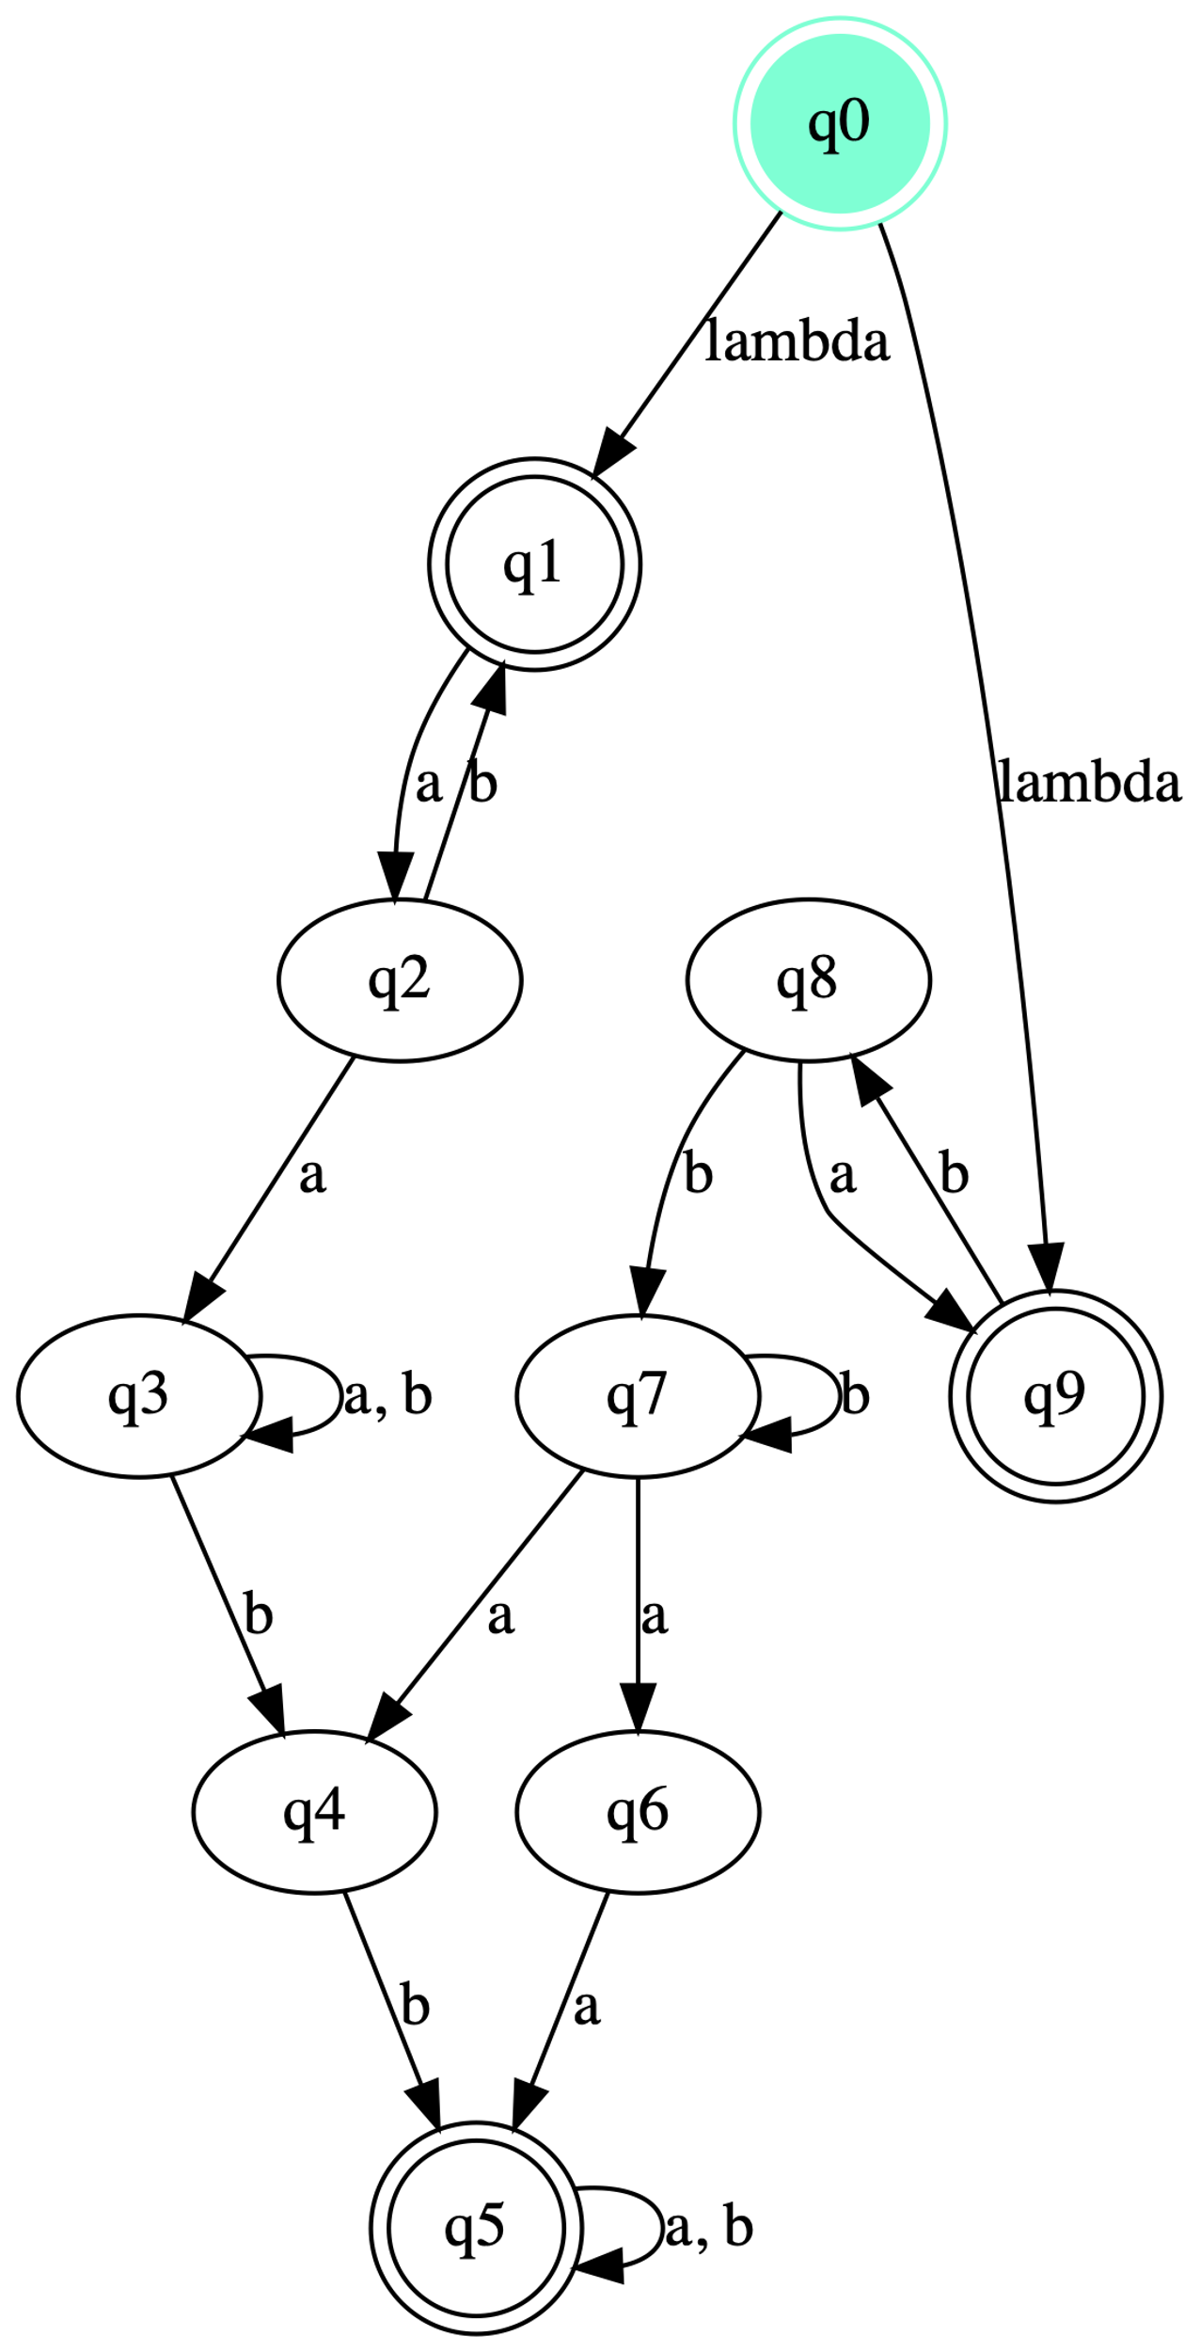

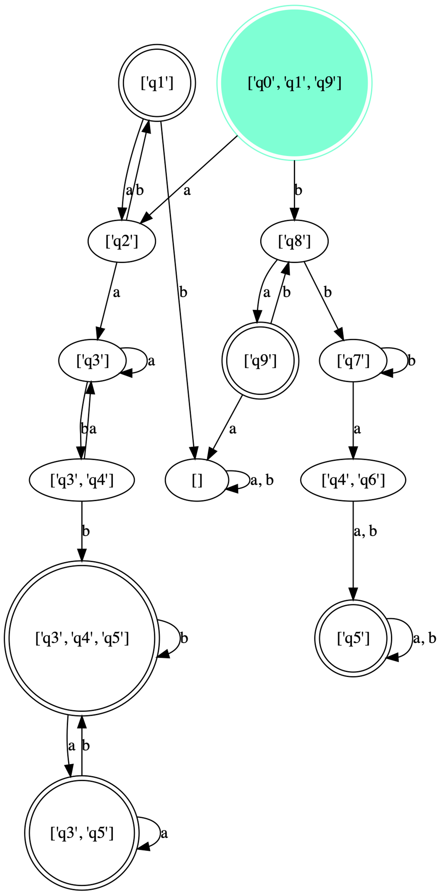DFA

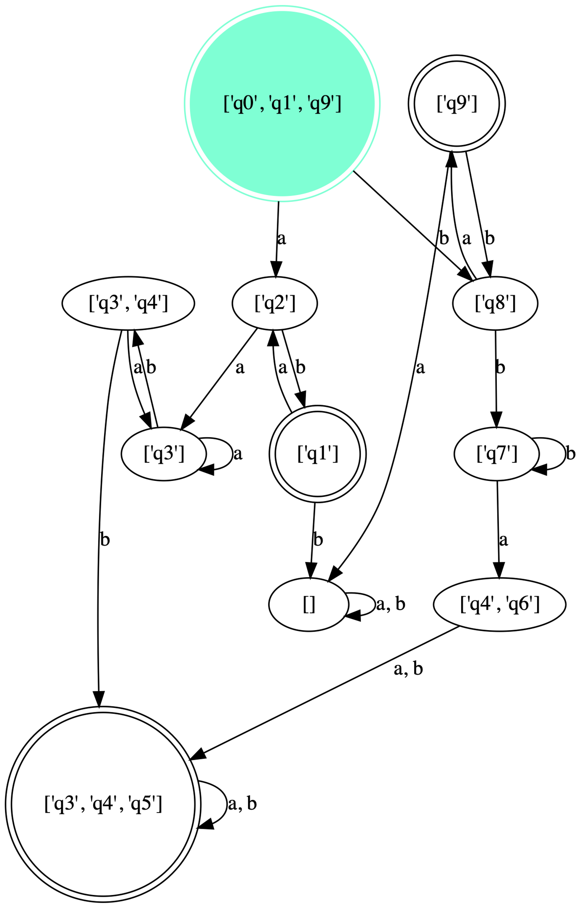DFA MINIMIZE

\*\*\* Provided NFA

q: ['q0', 'q1', 'q2', 'q3', 'q4', 'q5', 'q6', 'q7', 'q8', 'q9']

Sigma: {'b', 'a'}

q0: q0

F: ['q0', 'q1', 'q5', 'q9']

delta:

+-------+--------------+--------------+--------------+

| delta | a | b | lambda |

+-------+--------------+--------------+--------------+

| q0 | | | {'q1', 'q9'} |

| q1 | {'q2'} | | |

| q2 | {'q3'} | {'q1'} | |

| q3 | {'q3'} | {'q3', 'q4'} | |

| q4 | | {'q5'} | |

| q5 | {'q5'} | {'q5'} | |

| q6 | {'q5'} | | |

| q7 | {'q4', 'q6'} | {'q7'} | |

| q8 | {'q9'} | {'q7'} | |

| q9 | | {'q8'} | |

+-------+--------------+--------------+--------------+

t-table:

+----+--------------+--------------+

| t | a | b |

+----+--------------+--------------+

| q0 | {'q2'} | {'q8'} |

| q1 | {'q2'} | |

| q2 | {'q3'} | {'q1'} |

| q3 | {'q3'} | {'q3', 'q4'} |

| q4 | | {'q5'} |

| q5 | {'q5'} | {'q5'} |

| q6 | {'q5'} | |

| q7 | {'q4', 'q6'} | {'q7'} |

| q8 | {'q9'} | {'q7'} |

| q9 | | {'q8'} |

+----+--------------+--------------+

\*\*\* Converted DFA

q: ["['q0', 'q1', 'q9']", "['q1']", "['q2']", "['q3', 'q4', 'q5']", "['q3', 'q4']", "['q3', 'q5']", "['q3']", "['q4', 'q6']", "['q5']", "['q7']", "['q8']", "['q9']", '[]']

Sigma: {'b', 'a'}

q0: ['q0', 'q1', 'q9']

F: ["['q0', 'q1', 'q9']", "['q1']", "['q3', 'q4', 'q5']", "['q3', 'q5']", "['q5']", "['q9']"]

delta:

+--------------------+--------------+--------------------+

| delta | a | b |

+--------------------+--------------+--------------------+

| ['q0', 'q1', 'q9'] | ['q2'] | ['q8'] |

| ['q1'] | ['q2'] | [] |

| ['q2'] | ['q3'] | ['q1'] |

| ['q3', 'q4', 'q5'] | ['q3', 'q5'] | ['q3', 'q4', 'q5'] |

| ['q3', 'q4'] | ['q3'] | ['q3', 'q4', 'q5'] |

| ['q3', 'q5'] | ['q3', 'q5'] | ['q3', 'q4', 'q5'] |

| ['q3'] | ['q3'] | ['q3', 'q4'] |

| ['q4', 'q6'] | ['q5'] | ['q5'] |

| ['q5'] | ['q5'] | ['q5'] |

| ['q7'] | ['q4', 'q6'] | ['q7'] |

| ['q8'] | ['q9'] | ['q7'] |

| ['q9'] | [] | ['q8'] |

| [] | [] | [] |

+--------------------+--------------+--------------------+

+++ Map of state number to state name serving as the legend in triangle:

0 | ['q0', 'q1', 'q9']

1 | ['q1']

2 | ['q2']

3 | ['q3', 'q4', 'q5']

4 | ['q3', 'q4']

5 | ['q3', 'q5']

6 | ['q3']

7 | ['q4', 'q6']

8 | ['q5']

9 | ['q7']

10 | ['q8']

11 | ['q9']

12 | []

+++ Marked all pairs of states where one is a final state, while the other is not

0

1 1

0 0 1

1 1 0 1

0 0 1 0 1

1 1 0 1 0 1

1 1 0 1 0 1 0

0 0 1 0 1 0 1 1

1 1 0 1 0 1 0 0 1

1 1 0 1 0 1 0 0 1 0

0 0 1 0 1 0 1 1 0 1 1

1 1 0 1 0 1 0 0 1 0 0 1

-------

+++ Triangle filled

3

1 1

2 2 1

1 1 3 1

2 2 1 0 1

1 1 2 1 2 1

1 1 2 1 2 1 2

2 2 1 0 1 0 1 1

1 1 2 1 2 1 3 2 1

1 1 2 1 2 1 2 2 1 2

3 3 1 2 1 2 1 1 2 1 1

1 1 2 1 2 1 3 2 1 3 2 1

-------

\*\*\* Minimized DFA

q: ["['q0', 'q1', 'q9']", "['q1']", "['q2']", "['q3', 'q4', 'q5']", "['q3', 'q4']", "['q3']", "['q4', 'q6']", "['q7']", "['q8']", "['q9']", '[]']

Sigma: {'b', 'a'}

q0: ['q0', 'q1', 'q9']

F: ["['q0', 'q1', 'q9']", "['q1']", "['q3', 'q4', 'q5']", "['q9']"]

delta:

+--------------------+--------------------+--------------------+

| delta | a | b |

+--------------------+--------------------+--------------------+

| ['q0', 'q1', 'q9'] | ['q2'] | ['q8'] |

| ['q1'] | ['q2'] | [] |

| ['q2'] | ['q3'] | ['q1'] |

| ['q3', 'q4', 'q5'] | ['q3', 'q4', 'q5'] | ['q3', 'q4', 'q5'] |

| ['q3', 'q4'] | ['q3'] | ['q3', 'q4', 'q5'] |

| ['q3'] | ['q3'] | ['q3', 'q4'] |

| ['q4', 'q6'] | ['q3', 'q4', 'q5'] | ['q3', 'q4', 'q5'] |

| ['q7'] | ['q4', 'q6'] | ['q7'] |

| ['q8'] | ['q9'] | ['q7'] |

| ['q9'] | [] | ['q8'] |

| [] | [] | [] |

+--------------------+--------------------+--------------------+

Enter the string to simulate. Press enter to exit: abba

['q0', 'q1', 'q9'] -- a --> ['q2'] -- b --> ['q1'] -- b --> [] -- a --> [] REJECT

Enter the string to simulate. Press enter to exit: baab

['q0', 'q1', 'q9'] -- b --> ['q8'] -- a --> ['q9'] -- a --> [] -- b --> [] REJECT

Enter the string to simulate. Press enter to exit:

affanmoyeed@wireless148-192 assignment 3 5800 %